Project Title: Network Design for a Small Business
Total Points 100
Introduction:
The purpose of this project is to design a network for a small business that consists of five departments with 40 employees each. The network must be able to provide reliable and secure connectivity for all employees and must support the company's current and future needs. The network must also be scalable and cost-effective.

Network Diagram Example/Sample:
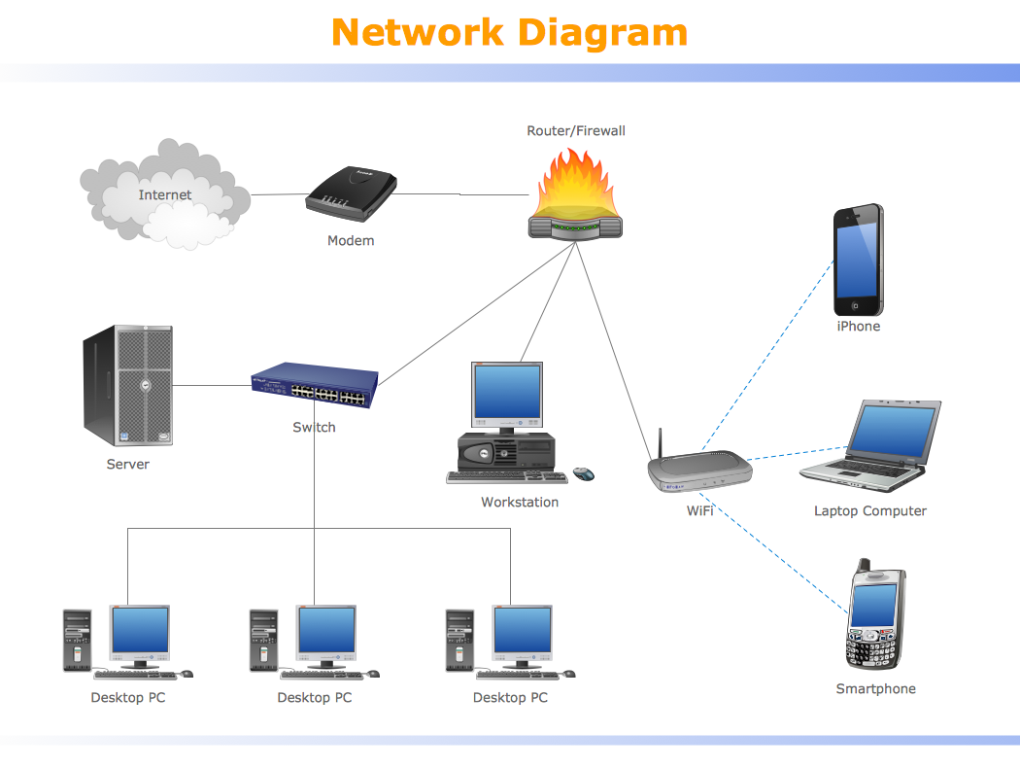

- Network Design Diagram Points [20]
- Build redundancy into your Network Architecture [10]
- Network Design:[10]
Network Topology: The recommended network topology for the small business is a star topology. This topology provides a centralized control mechanism that allows for easy management and troubleshooting. It also allows for easy expansion and addition of new devices.
- Network Infrastructure: [30]
The network infrastructure consists of the following components:
Points[10] Switches: The network consists of five switches, one for each department. Each switch connects to the router and provides connectivity to the devices in the respective department.
Points[10] Router: The router connects the network to the internet and provides network security by implementing firewall and VPN services.
Points[10] Wireless Access Points (WAPs): The network has two WAPs strategically placed to provide wireless connectivity to all devices in the office.
- Network Security: [30]
The network security features include the following:
Points[8] Firewall: The router will be configured with a firewall to prevent unauthorized access to the network.
Points[8] VPN: The router will be configured with a VPN to provide secure remote access to the network.
Points[7] Antivirus Software: Each device on the network will be installed with an antivirus software to prevent malware infections.
Points[7] Configure VLANs: Define three VLANs for Finance depart, Standard Users and Administrators.
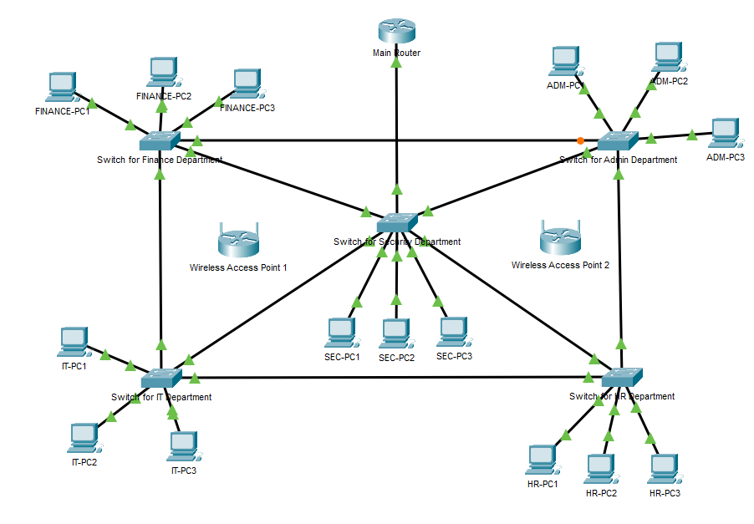
My Network Topology Diagram (I used cisco packet tracer to build this diagram):
As Cisco Packet Tracer may crash if I were to add 40 users (PCs) per each department switch, I only added 3 PCs for each to combat that.

Network Equipment
Network Infrastructure:
- Switches:
  - Vendor: Cisco
  - Model: Catalyst 2960-X Series
  - Key Features:
    - Port Configuration
      - Supports 48 Gigabit Ethernet ports for device connections
      - 4 SFP uplink ports
    - Switching Capacity: 216 Gbps
    - Security Features:
      - 802.1X authentication
      - Access Control Lists (ACLs) for traffic filtering
      - Port Security and DHCP Snooping
  - Price: $225 through amazon, although it is refurbished. In total counting 5 departments, it is $1,125
- Router:
  - Vendor: Cisco
  - Model: RV340
  - Key Features:
    - Dual WAN Gigabit VPN router
    - Built-in Stateful Packet Inspection firewall
    - Web-based GUI for configuration
    - Supports up to 100 users/devices
    - 2 Gigabit WAN ports for load balancing
    - 4 Gigabit LAN ports for direct device or switch connections
    - Supports VLANs to segment network traffic
  - Price: $370 USD through Amazon
- Wireless Access Points (WAPs):
  - Vendor: Cisco
  - Model: Catalyst 9105AX Series
  - Key Features:
    - Ideal for dense environments
    - Supports Wi-Fi 6 (802.11ax)
    - WPA3 Encryption
    - Segmented SSIDs using VLANs
  - Price: Lowest price goes to $799, according to ITPrice.
Network Security:
- Firewall:
  - Vendor: Cisco
  - Model: Firepower 1120
  - Key Features:
    - Up to 2.3 Gbps throughput
    - Supports 150 VPN Peers
  - Price: $2292.99 USD
- VPN:
  - Vendor: Cisco
  - Model: AnyConnect Secure Mobility Connect
  - Key Features:
    - Supports integration with
      - Cisco Duo
      - Smart cards
      - Certificates
    - Enables split tunneling / full tunnel
      - All traffic goes through VPN (Full Tunnel)
      - Only corporate traffic goes through (Split Tunnel)
    - As we are using Cisco Firepower 1120, Cisco Firepower Management Center can also configure and manage the VPN settings.
  - Price: $32.99 per user for 5 years. So depending on per department, 40 users will equal $1319.60
- Antivirus Software:
  - Vendor: Cisco
  - Model: Secure Endpoint
  - Key Features:
    - Cloud-managed
    - Integrates well with Cisco Firepower and SecureX
    - Excellent for work environments using Cisco AnyConnect
    - Protects against malware, ransomware, and zero-day exploits
    - Uses machine learning, and behavior monitoring
    - Can detect and block attacks before they execute
  - Price: $93.60 USD for 1 year per user. When totaling for a department, it equals $3,744 USD
Conclusion:
Through this final project, I have gained experiences designing and implementing a secure and scalable network for a small business using Cisco Packet Tracer. I have learned how to apply essential networking concepts such as VLAN segmentation, trunking, and inter-VLAN routing to isolate and manage traffic across departments. In addition, I have implemented access control lists (ACLs) to simulate a basic firewall. This experience improved my understanding of how network design works in the real-world, giving me insight into how they are built and secured.

